# 004020000022201049A5310

**French OPeN CHAT Sessions**

**Saturday 12th & 26th August 10.00 – 11.00am.**

Practise or brush up on your French speaking skills by coming along to an open chat session.

**POETRY GROUP**

**Friday 25th August 2.00-3.00pm.**

A Poetry Group meets at the library

on the last Friday of each month,

from 2.00 – 3.00pm.

New readers/writers, experienced or otherwise are welcome.

---------------------------

**Sunday Afternoon Tea at Beccles Library**

 

**Sunday 6th & 20th August**

**1.30pm – 3.00pm**

Just come along for an informal cup of tea and a slice of cake and a chat! We have quizzes, easy crafts, daily papers and shared conversation.

Donations welcome.

**Beccles Library Lego Club**

**@ Beccles Library**

**The next Lego Club will be on Sunday 13th August from 10:00–11:00am, and monthly thereafter.**

We welcome children over the age of 5 to come and start building together in a friendly and safe space.  
Donation of £1 recommended**.**



**Please ask a member of staff for more information:**

**consumer Advice, Healthwatch and Fire safety Drop-In**

**Tuesday 1st August 10.00 am -12.00.**

Consumer Champion Rhoda Staley will be on hand to offer advice about consumer rights,

fire prevention and fire safety.

**CREATIVE WRITING**

**\*\*\*\*NEW DAY AND TIME!!!\*\*\*\***

**Tuesday 1st August 2.00 – 4.00pm**

Join local writers on the first Tuesday of

each month.

New members welcome.

**TOP TIME BOOK GROUP**

**Thursday 3rd August 2.00 – 3.00pm.**

The group will be discussing ‘A Shepherd’s Life’ by James Rebanks. Come along for a relaxed discussion, with tea and coffee. Pick up a copy of next month’s book to discuss in September.

**BECCLES LIBRARY READING GROUP**

**Monday 7th August 7.00 – 8.30pm**

Come along to a friendly, welcoming Reading Group after hours, on the first Monday of each month at 7.00pm**.**

For more information, please contact Ruth

Sainsbury.[**ruthsainsbury@yahoo.co.uk**](mailto:ruthsainsbury@yahoo.co.uk)

**GERMAN CONVERSATION**

**Tuesday 8th & 22nd August 2.00 – 4.00pm**

Come and join us for German conversation on the second and fourth Tuesday of each month at Beccles Library.

If you have some previous knowledge of conversational German, from elementary to native level, we would love to see you.

For further details please contact Chris Greenhill on 01502 715733.

***Forthcoming Events at***

***Beccles Library***

***August 2017***

***The Friends of Beccles Library present***

***The Future of Artificial Intelligence with Ben Taylor***

***Friday 4th August @ 7.00pm***

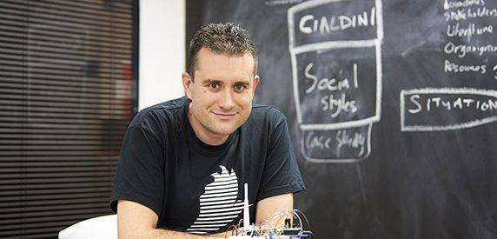

**The talk will be delivered by CEO of Rainbird, computer scientist and expert in his field, Ben Taylor.**

**Doors open 7:00pm  
Wine and nibbles served  
Talk commences 7:15 - 30 mins.  
Brief break.  
Questions from the floor**

**Tickets £3 - to help raise funds for Beccles Library.**

***Top Time Open House***

***Thursday 24th August***

***2.00 – 3.00pm***

***Wirework Jewellery***

***Just use your imagination to design and make a beautiful piece of jewellery…***





*All materials and tools supplied.*

*No experience necessary.*

***£2.50 per person.***

**No need to book – just come along.**

*All materials and tools supplied.*

*No experience necessary.*

***£2.50 per person.***

**No need to book – just come along.**

***Top Time Open House***

***Thursday 17th August***

***2.00 – 3.00pm***

***Suffolk Historic Churches Trust***

Celia Stephens from Suffolk Historic Churches Trust is our guest speaker, and will be talking about the History of the Trust; grants for repairs and maintenance; the annual sponsored ‘Bike Ride’ and other events.

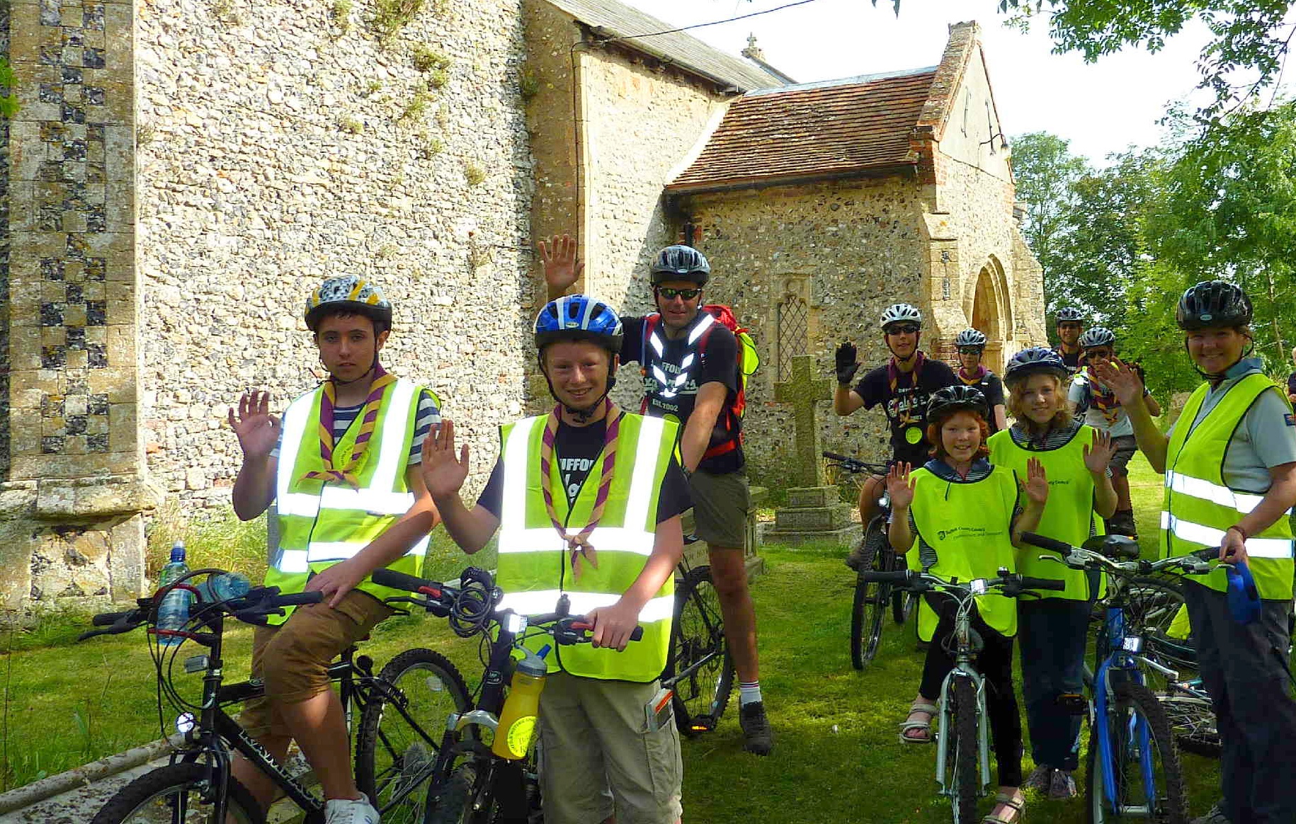

*THE SPONSORED BIKE RIDE*

*9th September 2017*

The sponsored bike ride event is the Trust’s biggest fundraiser and is held annually on the second Saturday in September. It started here in Suffolk in 1982 and has now spread, as ‘Ride & Stride’, across the country. The money raised is shared between the participant’s chosen church and Suffolk Historic Churches Trust. Sponsors are now able to donate via .

For more information about donating or taking part in the Suffolk Historic Churches Bike Ride visit our website: [www.shct.org.uk](http://www.shct.org.uk)

***No need to book. Refreshments available.***

***Top Time Open House***

***Thursday 10th August***

***2.00 – 3.00pm.***

***Quiz***



*Do you enjoy a challenge?*

*Come along and take part in our new afternoon quiz.*

*Topics to include a picture round, multiple choice and questions whose answers begin with the letter N!*

*(You do not need to be in a team – this is a quiz for individuals.*

***Free to attend. No need to book. Tea and coffee provided.***

***------------------------------------------***

*We will also be drawing the winners of the* ***Beccles Library 100 Club.***

*Prizes of* ***£25*** *and* ***£15*** *every month.*

*For just £1 per month you are supporting your local Library!*

*Please ask for a form to join.*



